Thurles Community Choir Group – New Members 2025 – Questionnaire
TCC returns on Saturday, October 4th, 2025 for new and existing members. The secular Community Choir with Mentor Eamon O'Malley, runs every second Saturday in Autumn/Winter and Spring.
It starts at 10.30 am -and runs until 1 p.m. I This project is for over 18's only
New members welcome, especially male voices. Please fill out the details below and email: admin@sourcearts.ie if you are interested in joining.
1. Name: _________________________________________

2. Age (or age group) - I am
☐ Under 18 ☐ 18–30 ☐ 31–50 ☐ 51–70 ☐ 71+
3. Contact details (phone/email):
Phone: ________________________________________ Email: _________________________________________

4. Musical background (if any):
☐ None – just enthusiasm!
☐ Some school/college singing
☐ Previous choir experience
☐ Instrumentalist / other musical skills
Other_________________________________________

5. What interests you about joining the choir? _________________________________________________________________________________________________________
_________________________________________________________________________________________________________
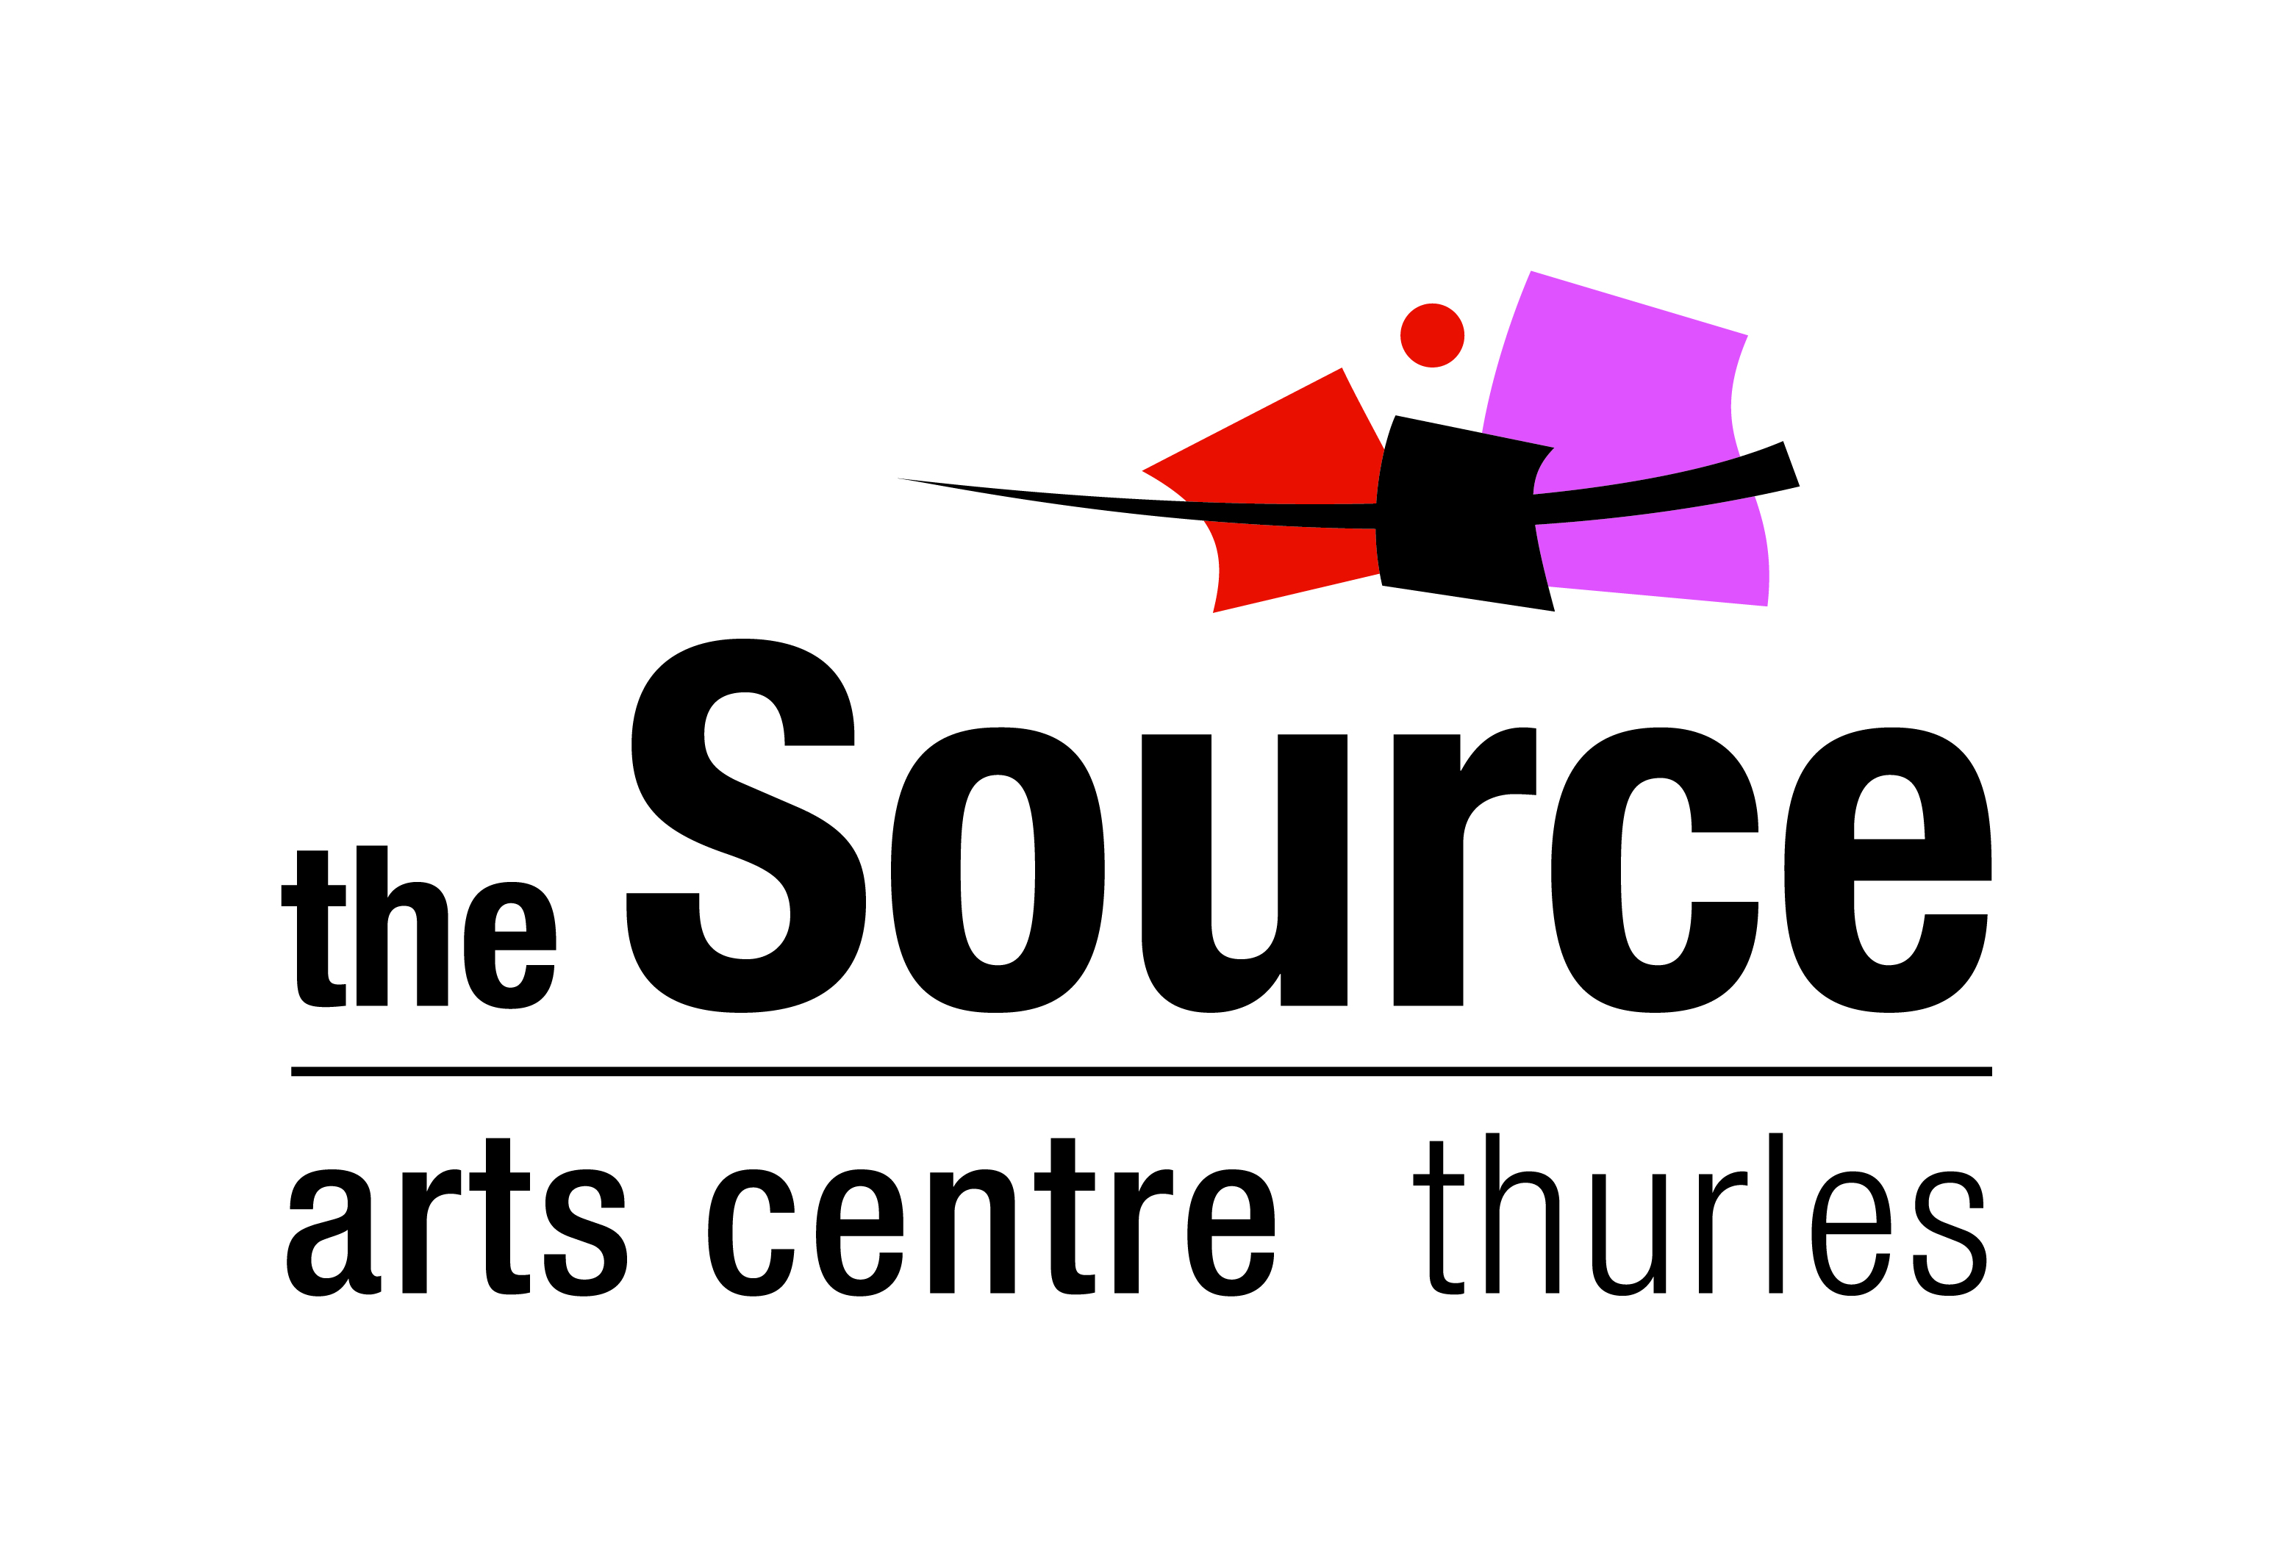
6. Preferred voice part (if known):
☐ Soprano ☐ Alto ☐ Tenor ☐ Bass ☐ Not sure yet

